EarthCorps Field Projects
Crews complete restoration projects in partnership with various land management agencies, throughout the Puget Sound region (in urban, suburban, and rural settings). Here are just a few of these projects and agency partners we wanted to share with you.
EarthCorps Making a Difference video (2019)
Amy Cirio, EarthCorps 2019-2020 Alumna, video talks about Amy’s experience serving at EarthCorps in 2020

Invasive Species Removal & Rain Gardens
Project Name: Surface Water Management– Green Stormwater Infrastructure Maintenance
Agency: City of Shoreline
Land Acknowledgement: These rain gardens and the City of Shoreline sit on occupied territory of Coast Salish and Snohomish People. It is vital that as we work in the field of restoration and during this project, that we take time to acknowledge the history of the people who rightfully own this land. From the Snohomish Tribe Website:
"The Snohomish Tribe has functioned as a sovereign nation since time immemorial. And while a political late-comer to the area is thwarting our efforts and affecting our lives, we maintain a firm belief in the sanctity and integrity of the Treaty of Point Elliott and the Constitution of the United States of America. Many of our members have defended that constitution with our lives; how can the American Nation turn its collective back on our people when we seek justice?" -Jack Kidder, Snohomish Historian and Hereditary Chief
Project Goals/Overview: We are the plant experts for the City of Shoreline. Using our care and expertise, EarthCorps crews will maintain curb side rain gardens and bio-retention facilities. Each site will be maintained five times throughout the year (April, May, June, Aug, Oct, and Dec).
Project Outcomes: One barrier for agencies when installing rain gardens is the cost of maintenance. EarthCorps increases the capacity for Shoreline’s Surface Water Management team. We help Surface Water:
- manage stormwater drainage
- reduce flooding
- prevent water pollution
Tasks:
- Weed planting areas
- Remove trash
- Trim overhanging vegetation along paved edges

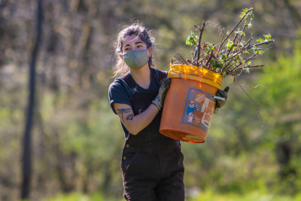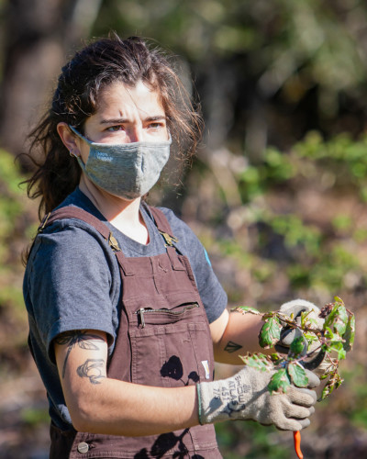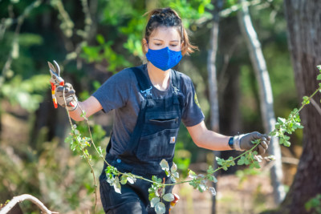

Site Stewardship Project
Project Name: Elliot Bay/Duwamish River Restoration Program
Agency: NOAA’s Damage Assessment, Remediation and Restoration Program (DARRP)
Land Acknowledgement:
The Lower Duwamish river valley, City of Seattle, and Elliot Bay are located on the stolen and occupied land of the Coast Salish, Duwamish, Muckleshoot, Suquamish and other indigenous peoples. Industrialization and urbanization channelized and destroyed the habitat of salmon that these communities have fished for centuries. Our work as a part of the Elliot Bay/Duwamish River Restoration Program is centered on the restoration of salmon habitat for both ecological and cultural value. Please take time while working here to recognize the systemic oppression these tribes are still experiencing today. Our work is only a minor step in reclaiming this land and restoring it in a way that honors the land indigenous people have stewarded for millennia. Some of these tribes (except for the Duwamish Tribe) have direct representation on the board of trustees that govern our work and they continue to cooperate with us in creating effective restoration plans.
Project Goals/Overview:
The Elliott Bay/Duwamish River Restoration Program, a program associated with NOAA’s Damage Assessment, Remediation and Restoration Program (DARRP), has entered into a partnership with EarthCorps to provide habitat stewardship services for a total of four Duwamish River habitat restoration sites near Seattle Washington. A 1991 Natural Resource Damage Assessment and Restoration (NRDAR) settlement with the City of Seattle and King County resulted in the construction of these restoration projects, as well as other restoration activities. Long-term stewardship is now needed to maintain the conservation values of these sites over time. These habitat restoration sites were created involving much effort and expense, and can be degraded by invasive plant species, debris and other impacts.
The project is overseen by the Elliott Bay/Duwamish Restoration Program Panel which is made up of the following members:
- City of Seattle,
- King County,
- NOAA,
- US Fish and Wildlife Service,
- Washington Department of Ecology,
- Muckleshoot Indian Tribe, and
- The Suquamish Tribe.
EarthCorps has a two year agreement through the National Fish and Wildlife Federation (NFWF) to steward these four sites through 2022 (with the hopes that the agreement can be extended). Our main priorities are to maintain and enhance the functional habitat systems at these sites that provide valuable fish and wildlife resources. In addition, these riparian buffers protect against storm surges and shoreline erosion, enhance infiltration and retention of stormwater runoff, moderate temperature extremes, contribute large woody debris and detritus (that provide important habitat and prey resources for salmon and other marine animals), and help mitigate against the effects of sea level rise and climate change.

Invasive Plant Control & Herbicide Treatment
Project Name: Hazelwood Park
Agency: City of Newcastle
Land Acknowledgement: The City of Newcastle is located on the stolen and occupied land of the Coast Salish, Duwamish, Muckleshoot, Stillaguamish, and other indigenous peoples.
“The Coast Salish ancestral homelands, Salish Sea and people continue to face detrimental damages to the environment and resources based on the pollution based economy, and will continue to move on co-management and co-decision making on the Salish Sea and Biome.”
Project Goals/Overview:
Our work in Hazelwood park is a part of a greater tree and canopy replacement project. The City of New Castle and the surrounding residents of Hazelwood Park identified that the forest within the park has many deciduous trees that are sick and dying. Not only do these trees pose a hazard to the surrounding houses and the users of the park, the forest does not have a well-established “next generation” of trees. After surveying the Hazelwood park forest, it was determined that select trees will be removed for safety purposes. EarthCorps has been hired to replant the forest with native trees. We have three primary tasks for this project, control some bio barrier weeds such as blackberry and ivy, replant native trees and then maintain these plantings in 2021. The park has been broken into 3 phases of tree removal. EarthCorps completed most the initial work of plant management and planting in 2020.
Invasive Plant Control: An EarthCorps crew will sweep the project area for invasive plants. Targeted plants are: English holly (Ilex aquifolium), Himalayan blackberry (Rubus bifrons), English Ivy (Hedera helix) and knotweed (Polygonum spp.). Methods of control will follow current best management practices including mechanical, herbicide treatment, and manual control. Removed vegetation will be composted onsite.
